

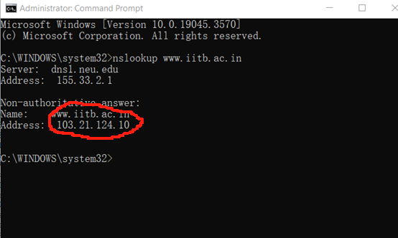

IP address is： 103.21.124.10



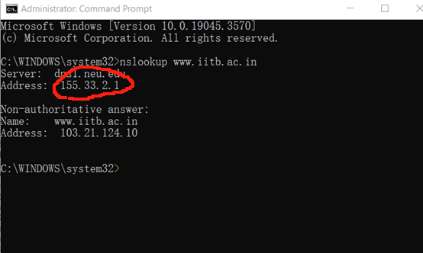

IP Address： 155.33.2.1



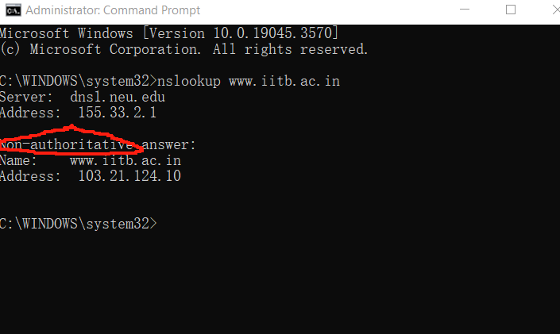

From a Non- authoritative server

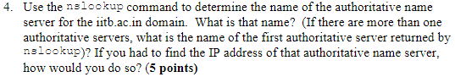

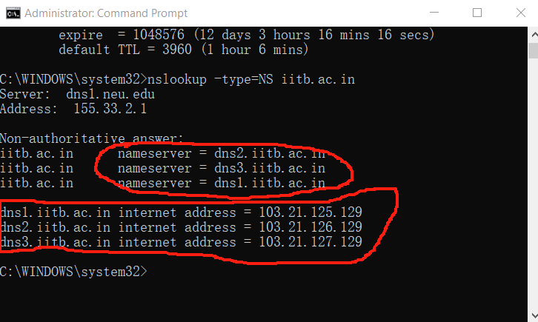

The first authoritative server is : dns2.iitb.ac.in

Run command nslookup -type=NS iitb.ac.in. The IP address will show.